What is Physical wellbeing
WHAT IT IS
Something that is often omitted when the subject of resilience is talked about is the importance of physical wellbeing as most of the literature focuses on emotional and psychological wellbeing. It is widely acknowledged now that there is a very close relationship between physical and mental/emotional health, so it is worthy of inclusion in developing good personal resilience. So why do so many people seem to neglect physical wellbeing until such time as a health crisis emerges? Its all to do with importance and urgency. Giving regular attention to being proactive with your physical health although most people would agree is important, it’s not urgent so you need a huge amount of willpower and commitment to give a daily and weekly priority to this area of your life.
Good physical wellbeing involves a focus on nutrition, exercise, sleep/relaxation and something that is often forgotten or neglected is adequate water intake to flush toxins out of the body.
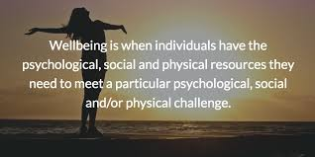
THE PROCESS
The starting point for this important area in our lives is to generate the commitment to be proactive and make the commitment to improvements to your physical wellbeing. Use honest self-awareness to ask yourself deeply how physically healthy you are, most of us can see others who are overweight, live unhealthy lifestyles but not so good at looking directly into the mirror! One of the keys to prioritising important things into our lives such as giving say 30 minutes or an hour every day to your physical health, is knowing what non-urgent, non-important (but often very pleasurable habits) things you are going to reduce or even say ‘NO’ to, what will they be? Excessive: TV? Computer games? Social media? Needless gossip/complaining? Waste of time meetings? Etc. These are important decisions to make, to start doing something very important you will need to say ‘No’ to some things that are less important or not important at all. This is easier said than done, but it is unlikely you’ll look back on your life in your twilight years and wish you had watched more TV!!
To understand personal change, we need to understand that fundamentally human beings change for one of two reasons, inspiration or desperation, pleasure or pain. Unfortunately, it would seem so many people wait until they are desperate or in pain before they focus on their physical health. So, before we start to think about our physical health plan, we need to attach ourselves to enough desperation and possible future pain to push us to change, then enough inspiration and possible future pleasure to pull us to change.
We refer to this desperation/pain as creating a ‘burning platform’ to change. Imagine you are stood on a burning platform, the first thing you will notice is the ‘heat under your feet’. This is creating discomfort with your current health habits. If (which we are sure you are not) you are someone who regularly eats to much processed or unhealthy food, takes very little exercise and drinks very little water, really spend a few minutes asking yourself what could be the medium and long-term health implications of such a lifestyle? Continuing with our analogy of a burning platform, if we don’t create this discomfort with any current unhealthy habits we have, eventually a burning platform will collapse – needless to say, none of us want this, if your burning platform was in the ocean and it collapses you are likely to suffer a premature death!!
Once you have a push (burning platform) to change you then need the pull to change. The pull or inspiration/pleasure to change is creating a compelling vision of what your life will be like when you are physically as healthy as you can possibly be. Why not create a vision board with images, pictures and powerful words that depicts how your life could be if you were physically as healthy as you could possibly be? What would be possible? What would you do? How would your life be better?
Once you have created a burning platform and a compelling vision to change then the last thing you need is a plan that takes you away from your burning platform and towards your compelling vision. Consider including in your plan: nutrition; exercise; sleep/relaxation; water intake. If you build your diet around fruit, vegetables and good nutritious food, eliminate or minimise processed and junk food, take daily exercise (which will help you sleep better), have a routine to relax and sleep well, reduce your exposure to toxins (in your food, on your body and in your environment) and finally drink 2 – 3 litres of water a day you’ll be making a very good start. Consider using an electronic or traditional paper based weekly planner. Don’t procrastinate over this do it now and make the commitment to great physical wellbeing, if you put it off now, it’s unlikely you’ll do it until you have to and then it’s often too late.
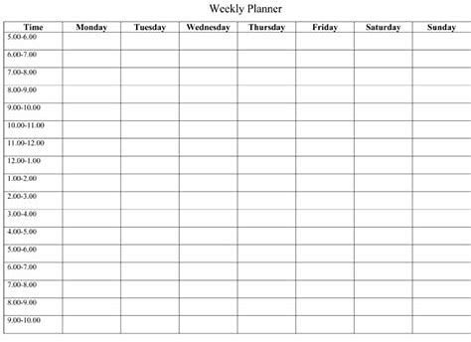
When you have your plan in place commit to it for 4 weeks, without any excuses, then recognise and maybe celebrate in a small way your progress, then repeat for another 4 weeks and then repeat this process until it becomes an empowering, positive continually evolving and improving part of your life. Take action, recognise progress, celebrate and repeat. Will it be difficult? Absolutely, and if you’re serious about this and taking exercise from a standing start then you will ache and even hurt at times, and so many people quit during the first few days/weeks, so don’t be one of those quitters, be one of those that commits to it and then enjoy the fruits of a fulfilling life full of vigour and vitality.
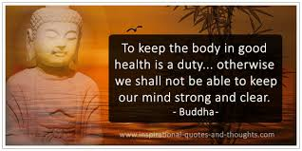
KEY POINTS AND PRACTICAL TIPS
- To start changing our lives in positive way that leads to optimum health, needs an investment of time, so know what you will STOP doing. If it is important to you, you will find the time, otherwise you will find an excuse – which do you want?
- Create a burning platform to push you to change.
- Create a compelling vision to pull you to change.
- Create a health and wellbeing plan and make a total commitment to it for 4 weeks. Then repeat this until you are sure it’s become a ‘way of life’ for you.
- Include in your plan food intake/nutrition, exercise, relaxation/sleep, reduced toxicity and water intake.
- Most good quality gyms provide a health check, so this is good to build into your plan. If you don’t join a gym how will you access your health MOT?
- The positive benefits to a physical health plan can be subtle so be in tune with how you feel now and then assess how you are feeling every month.
- If you drive a petrol car you would not put diesel in it as it would not work. Think of your body in the same way and give it the best that you can.
- On a score of 0 – 10 how important is your physical wellbeing? Write it down. What would you need to do to elevate that score to 10 if it’s not already? Will your physical wellbeing plan reflect the importance you place on this important area of life? Consider taking caring for yourself a top priority.
- By getting in the good habits of setting physical wellbeing goals, setting other goals in life also becomes easier.
- With fitness goals start small and increase it and as you get into it, work hard at your fitness so you release endorphins – it’s a magical feeling that makes us feel happier and positive.
- Commit to daily activity – in all 4 key areas (nutrition, exercise, sleep/relaxation & water intake – your body is 60% water!!).
- Make the core of your diet fruit & veggies – in time your palate will love it.
- Bring variety into your exercise and diet but keep it honest and nurturing!
- Recent studies have said that as many as 75% of us are overweight or obese, make a decision (our destiny is determined by the decisions we make) to be one of the 25%.

THE BENEFITS
- Longer life!
- Reduced risk of heart attack, cancer, diabetes, stroke and other nasties by up to 50% (NHS choices website).
- Good physical wellbeing helps with confidence and self-esteem.
- When you join a gym or health related club, you’ll meet other positive uplifting people who can be an inspiration.
- Improved quality of life – not only will you look better, you’ll feel better.
- Improved focus, performance, sleep and energy levels.
- Decreased risk of depression, anxiety and other mental and emotional health issues including dementia.
The following statistics are on the NHS choices website, they speak for themselves:
- up to a 35% lower risk of coronary heart disease and stroke
- up to a 50% lower risk of type 2 diabetes
- up to a 50% lower risk of colon cancer
- up to a 20% lower risk of breast cancer
- a 30% lower risk of early death
- up to an 83% lower risk of osteoarthritis
- up to a 68% lower risk of hip fracture
- a 30% lower risk of falls (among older adults)
- up to a 30% lower risk of depression
- up to a 30% lower risk of dementia

DON’T WAIT UNTILL YOU ARE FORCED TO GIVE PHYSICAL WELLBEING A TOP PRIORITY IN YOUR LIFE – PREVENTION IS BETTER THAN TRYING A CURE!!
FIND OUT MORE
https://www.nhs.uk/live-well/exercise/exercise-health-benefits/
https://www.nhs.uk/conditions/stress-anxiety-depression/mental-benefits-of-exercise/ - get active for mental wellbeing
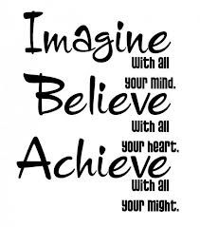

Our personal resilience facebook group called Ignite: Find Your Passion, Live Your Purpose & Re-Write Your Future: https://www.facebook.com/groups/216645969611627

