WHAT IS IT

It is a remarkably simple and easy to use method to involve staff in a discussion regarding what they have to gain/lose by making a change or not changing. In the workplace when change is announced people tend to think it will affect them adversely so resistance can be the natural response. Using a tool like the gain/loose matrix can help put the change into perspective, and also help people realise they might actually have more to gain from the change. In addition to change it can also be used in decision making to think about what can be gained/lost from various decisions.

THE PROCESS
Gain/Loss is an interactive ‘tool’ that is best used either on a flip chart with a team of people or a piece of paper with one or two people. It is ideal to do when people are concerned about change, are complaining about it or you would like some input to the pluses and minuses for a decision you are considering. Even if there is not outward vocal resistance there could be silent resistance, which can often be harder to deal with, so with any organisational change the Gain/Loss matrix is a good tool to use in a proactive manner.
Commitment comes from involvement, so involving people in discussions about change/decisions can increase their commitment to it.
It starts by inviting staff to a session with you to explore what you have the gain/lose by the proposed change. If you are familiar with Kotter’s 8 stages of change, this particularly helps with the first three stages, creating the climate for change: stage 1 increase urgency; stage 2 Build the guiding team; stage 3 get the right vision. Remind people of the change or proposed change, and the compelling vision (ideal future) for this change and the reasons it needs to happen now (increasing urgency or creating a burning platform). In addition, share the importance of developing a committed team of people who can help guide the change and be influential in their approach.
Next draw up the following grid and invite your team to think about/brainstorm what they have to gain by embracing the change and not changing or resisting the change, and also what they have to lose by embracing the change and not changing or resisting the change.
This will help you to gauge what commitment there is to the change, and it can often be a ‘light-bulb’ moment for staff as they suddenly realise they have more to gain from embracing the change than resisting it. Peer pressure can also help with this shifting of mind-sets.
Once you’ve done this you can use it as an accountability tool. If you hear future concerns or complaining you can refer back to this session you did where we identified that we have more to gain by embracing the change than resisting it.
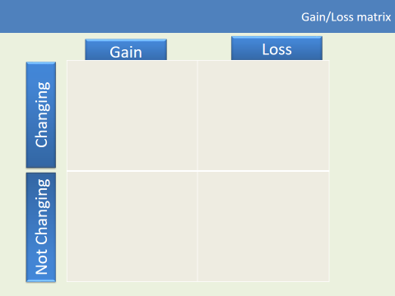

THE BENEFITS

- It is a simple but effective tool to use

- It helps with engagement, commitment and motivation and you will be able to get a sense of the levels of commitment within your team

- You need minimal resources, just a flip chart or piece of paper

- It helps put change into perspective i.e. there is often a lot to gain

- In can help to nip complaining and moaning in the bud

- It can help develop teamwork

- It can help you overcome silent resistance to change

- It can give information to help develop accountability towards a positive working culture

- Because of its simplicity your team can use it for changes/decisions they are making
- It can also be used ‘personally’ for personal change

