**WHAT IS IT**

It explains how, why, and at what rate new [ideas](https://en.wikipedia.org/wiki/Idea) and [technology](https://en.wikipedia.org/wiki/Technology) are adopted. [Everett Rogers](https://en.wikipedia.org/wiki/Everett_Rogers), a professor of [communication studies](https://en.wikipedia.org/wiki/Communication_studies), argues that it is the process by which an [innovation](https://en.wikipedia.org/wiki/Innovation) is communicated over time among the participants.

Rogers proposes that four main elements influence the spread of a new idea: the innovation itself, communication channels, time, and a social (or organisational) system. This process relies heavily on [human capital](https://en.wikipedia.org/wiki/Human_capital). The innovation must be widely adopted in order to become part of the norm, the culture or the way things are done. Within the rate of adoption, there is a point at which an innovation reaches [critical mass](https://en.wikipedia.org/wiki/Critical_mass_(sociodynamics)).

The categories of adopters are innovators, [early adopters](https://en.wikipedia.org/wiki/Early_adopters), early majority, late majority, and laggards. Diffusion manifests itself in different ways and is highly subject to the type of adopters and innovation-decision process. What is critical is the degree to which an individual adopts a new idea.

Adoption means that a person does something differently than what they had previously (i.e. perform a new behaviour etc.). The key to adoption is that the person must perceive the idea, behaviour, or product as new or innovative. It is through this that diffusion is possible.

Adoption of a new idea, behaviour, or product does not happen simultaneously, rather it is a process whereby some people are more apt to adopt the innovation than others.

The stages by which a person adopts an innovation, and whereby diffusion is accomplished, include awareness of the need for an innovation, decision to adopt (or reject) the innovation, initial use of the innovation to test it, and continued use of the innovation. There are five main factors that influence adoption of change, and each of these factors is at play to a different extent in the five adopter categories.

1. Relative Advantage - The degree to which an innovation is seen as better than the idea, program, or product it replaces.
2. Compatibility - How consistent the innovation is with the values, experiences, and needs of the potential adopters.
3. Complexity - How difficult the innovation is to understand and/or use.
4. Triability - The extent to which the innovation can be tested or experimented with before a commitment to adopt is made.
5. Observability - The extent to which the innovation provides tangible results.

**THE PROCESS**

You could draw up on a flip chart or whiteboard the following diagram and explain the theory briefly.

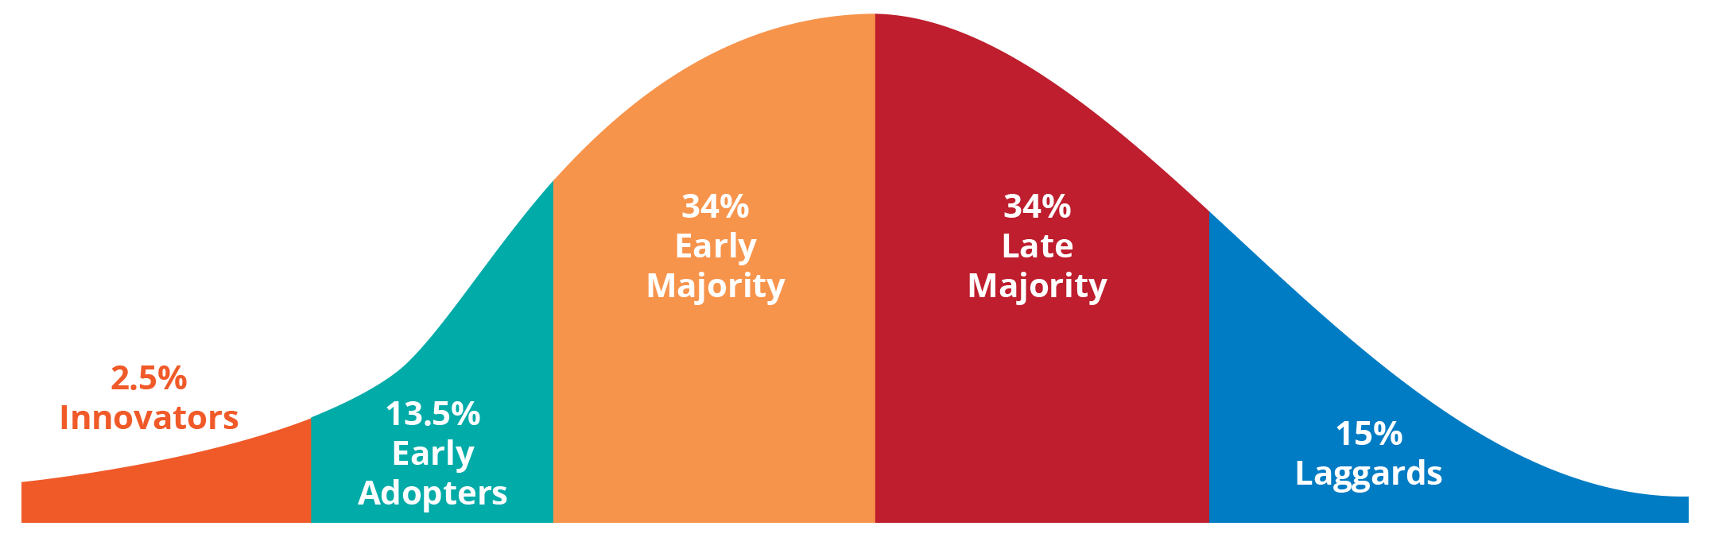

Then give each of your team a post-it note and ask them to write their name on it and then come up and stick it in the box which best describes their current thoughts on where they are with the change. You can then ask questions such as; what needs to happen to create a groundswell of us adopting this change? How can we support he innovators and early adopters with our team? How can we support the laggards and late majority to progress with us? Is there anything we can do within our team or the organisation to help progress the change? The early adopters are your likely change agents, think about how you will use them. You then need to hold people to account to where they placed their post-it note and the discussions you’ve had

**THE BENEFITS**

* It is a simple to use
* It encourages people to think about their own reaction to change
* It is relatively quick
* It helps nurture team-work and employee engagement
* It can be used to hold people to account