WHAT IS IT

PDCA, also known as the Deming cycle or PDSA (plan, do, study, act/adjust) was developed by renowned management consultant Dr William Edwards Deming in the 1950s as a way of identifying what caused products to fail to meet customers' expectations. His solution helps businesses to develop a methodology about what needs to change, and then test these in a continuous feedback loop. His focus was on predicting the results of an improvement, studying the actual results, then comparing them to possibly revise the course of action. The 4-stage process is used for continually improving a process, product or service, systematically testing possible solutions, assessing the results and implementing the ones that work. It is a great model for us to embrace personally to embark on a journey of personal continuous improvement.

The four phases are:

**Plan**: identify and analyse the problem or opportunity for you in the foreseeable future.

**Do**: take committed action for a minimum of 30-days and measure the results.

**Check/Study**: study the result, measure effectiveness, and decide what to do next.

**Act/Adjust**: on your study of the results in the previous step and make your next plan – you are now ‘continually improving’.

THE PROCESS

**PLAN**: It starts with identifying and understanding the challenges you want to overcome, or the opportunity available to you. Explore information, define the challenge, generate and screen ideas and develop an implementation plan. State your SMARTER (Specific, Measurable, Achievable, Realistic, Time bound, Exciting, Recorded) goals, so you can return to this in the check stage.

**DO**: Once you've identified your plan, test it with a small-scale pilot project. This will allow you to assess whether your proposed changes achieve the desired outcome. Set yourself a 30-day challenge. Make notes as you go along regarding the changes you are making and what impact they are having on you.

**CHECK**: Analyse your 30-day challenge results against your SMARTER objectives. If it hasn't worked, you return to Step 1. If it has worked, you go on to Step 4. You may decide to try out more changes, and repeat the Do and Check phases – don't settle for a less-than-satisfactory outcome – think and act big. Move on to the final phase (Act) only when you're genuinely happy with the 30-day outcome and are sure it’s a new habit in your life.

**ACT/ADJUST**: This is where you become 100% committed to your solution. But remember that PDCA / PDSA is a loop, not a process with a beginning and an end. This means that your improvement becomes the new baseline, and you continue to look for ways to make it even better for yourself. You are then evolving towards being a continually improving person.

THE BENEFITS

* Simple yet powerful to resolve new and recurring challenges in your life
* It allows testing of actions before making a life-long commitment to them
* It nurtures personal continuous improvement
* It develops the 3 C’s – *competence, confidence* and *commitment* which gives the joy of the 4th C – to *celebrate* your success.
* It helps give your life meaning, purpose and real fulfilment.

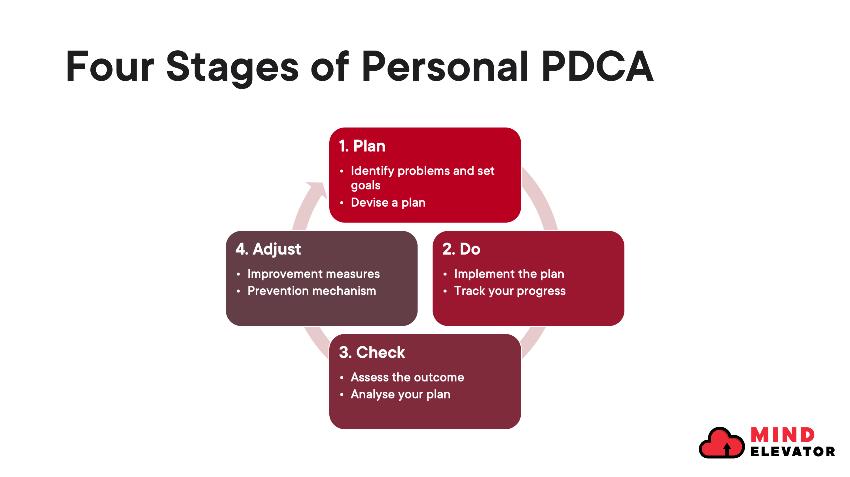

SUMMARY

It is so easy for all of us to remain in a comfort zone, but that can lead to a rut, and the difference between a rut and grave is about 12 inches so don’t get into a rut and one of the best ways to prevent that is to embrace PDCA and get yourself on a personal continuous improvement journey. By embracing PDCA for 90 days you will experience, see and feel such change you’ll be totally committed to this journey towards your vision of success.

Our facebook group.

Ignite: Find Your Passion, Live Your Purpose & Re-Write Your Future

<https://www.facebook.com/groups/216645969611627>