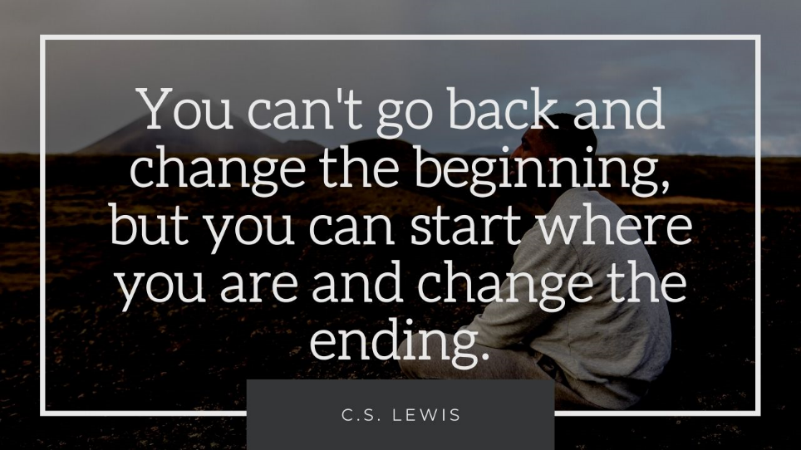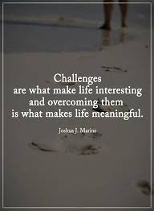

I think even if you are at rock bottom and feeling very low you can either stay there or decide to make tiny changes one step at a time to start building yourself the life you deserve and want. You have the power inside to flourish in your personal recovery. Also if you are at rock bottom then the only way to go is up!

Finding ‘keys’ to help you in the recovery journey. These could be anything from reading to training for a marathon and anything in between. However just because they have worked for you previously, they might not always be the ‘right key’ so you have to keep trying different ones! This is exciting as you have so many opportunities to find different things that you like to do!

“The only impossible journey is the one you never begin” – Tony Robbins

“You don’t have to see the full staircase, just take the first step” – Martin Luther king.

“Tell the story of the mountains you have climbed. Your words could become a page of somebody else’s’ survival guide one day” – Morgan Harper Nichols

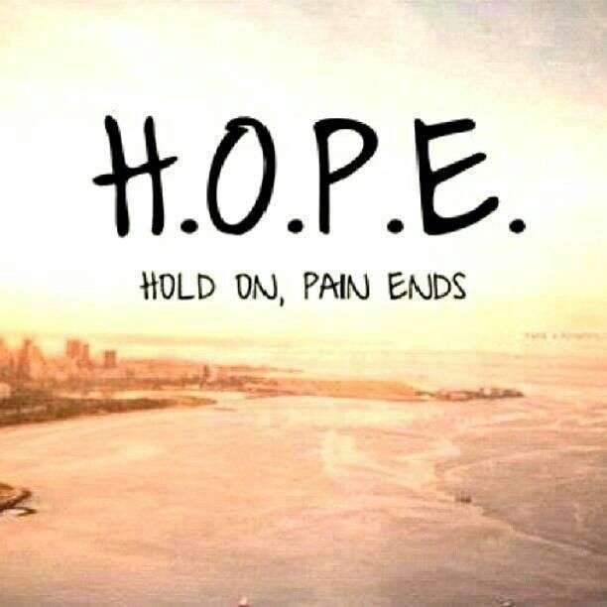

YOU are in the driver’s seat of your life. Not anyone else and especially not your illness! YOU decide what you want to do, where you want to go. You are in control and have the power to make these decisions! The right paths/decisions are not always the easiest choice but are always the most worth it!

There is always going to be challenges in your life, there will always be setbacks and tough times but you can fill your box full of ways to cope, of your keys to help you and slowly overtime the more times you use them and the more things you learn then the tough times become easier to manage and less painful. You have come so far already and faced so many battles that you are strong enough to face whatever comes your way because you are a warrior.

Recovery is a process/journey. Think of your final goal/what you really want to achieve, and you will get there. Think of recovery as a map and your final goal as the destination on that map. There are various ways to reach that place, however there are more direct ones (healthy coping strategies will take you more directly to that place) but even if you do stumble and have minor setbacks you will go in the opposite direction to where you need to go but that’s okay, it’ll just mean that it takes longer to get to the destination/goal but in the end you will get there and that is all that matters! Never give up!

HOPE. In recovery you need hope. Hope that things will get better, that you will become the person you want to be, that step by step you will recover from your illness. Our brains like to tell us there is no hope however I’ve seen people get better and having had periods of stability myself I KNOW it is possible!