**WHAT IS IT**

Created by Kurt Lewin in the 1940’s Force Field Analysis today, it is also used for making and communicating decisions and the forces for and against change. For change to happen, the driving forces must be strengthened or the resisting forces weakened, or both. In addition to being a decision making tool with change it is also useful for by communicating the reasoning behind your decision, and a employee engagement tool when used with staff.

**THE PROCESS**

Define and communicate the vision, goals and reason for the change/decision, then on a flip chart, whiteboard or piece of paper draw up the following.

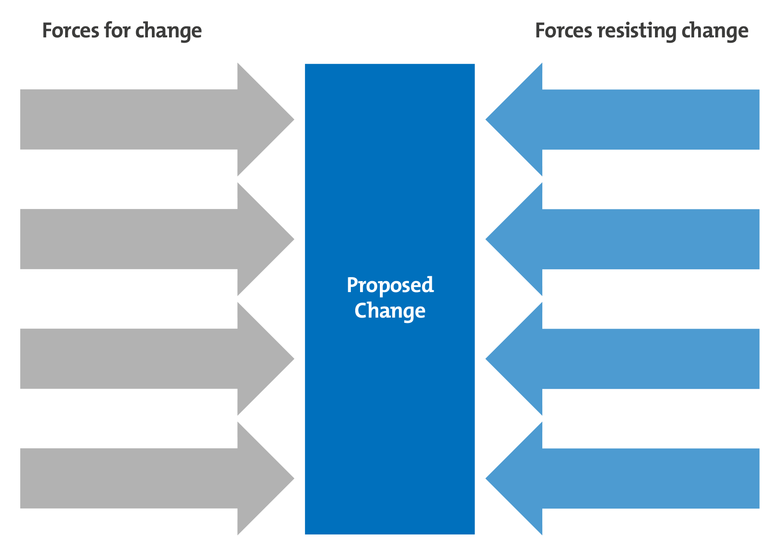

Then (with your team) identify the internal and external forces driving the change, then the internal and external unfavourable forces pushing back against the change. Some useful questions to ask include: What business benefit will the change deliver? Who supports the change? Who is against it? Why? Do you have the resources to make the change work? What costs and risks are involved? What business processes will be affected?

Then at the bottom, again with your team you can score (from 0 – 10 on their level of importance) each for driving or resisting the change, so you can then make decisions regarding the viability of the change, prioritise actions to minimise the effects of the resisters and exploit the driving forces to the full. There will always be driving forces that make change attractive to people, and restraining forces that work to keep things as they are. Successful change is achieved by either strengthening the driving forces or weakening the restraining forces. A completed aanlysis might look like this:

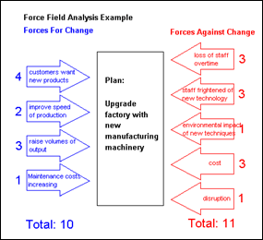

.

**THE BENEFITS**

* It is a simple and easy to use management tool
* When used ‘with the team’ it is a valuable employee engagement strategy
* It is relatively quick to use
* It aids better decision making
* It provides a visual summary of the various forces for and against change
* It helps identify obstacles that lie ahead so that we can make a plan to strengthen the forces supporting the decision and take actions to reduce or avoid the forces preventing it
* It helps to create a common understanding