**Somerset Recovery College**

**STUDENT HANDBOOK**

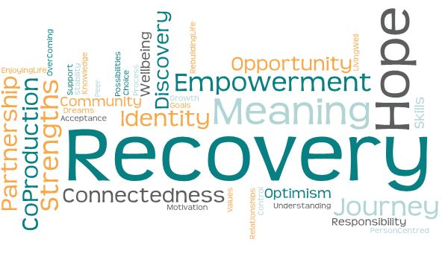



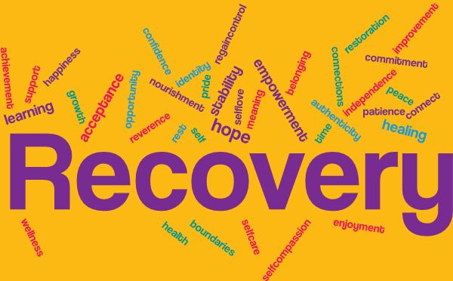

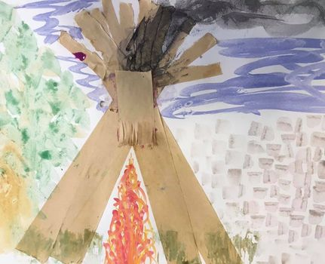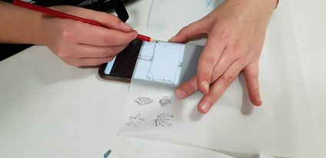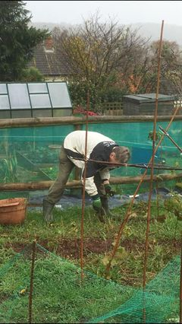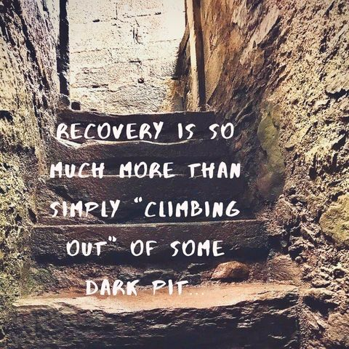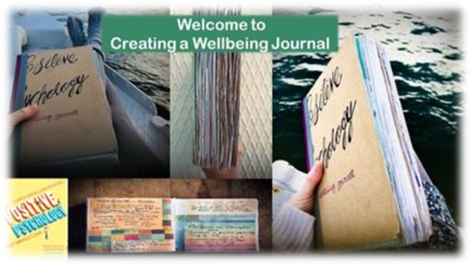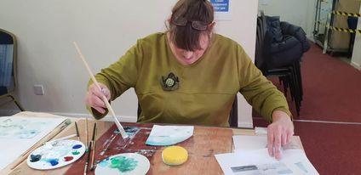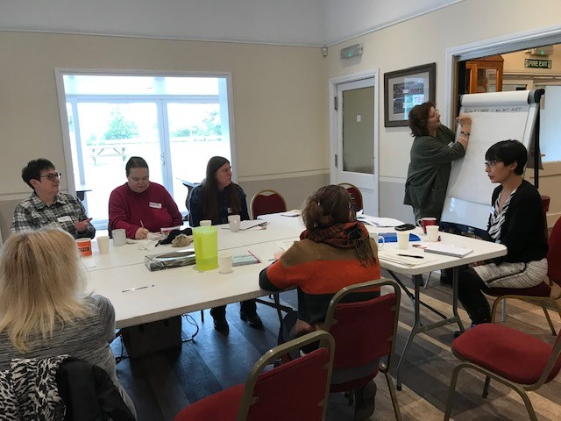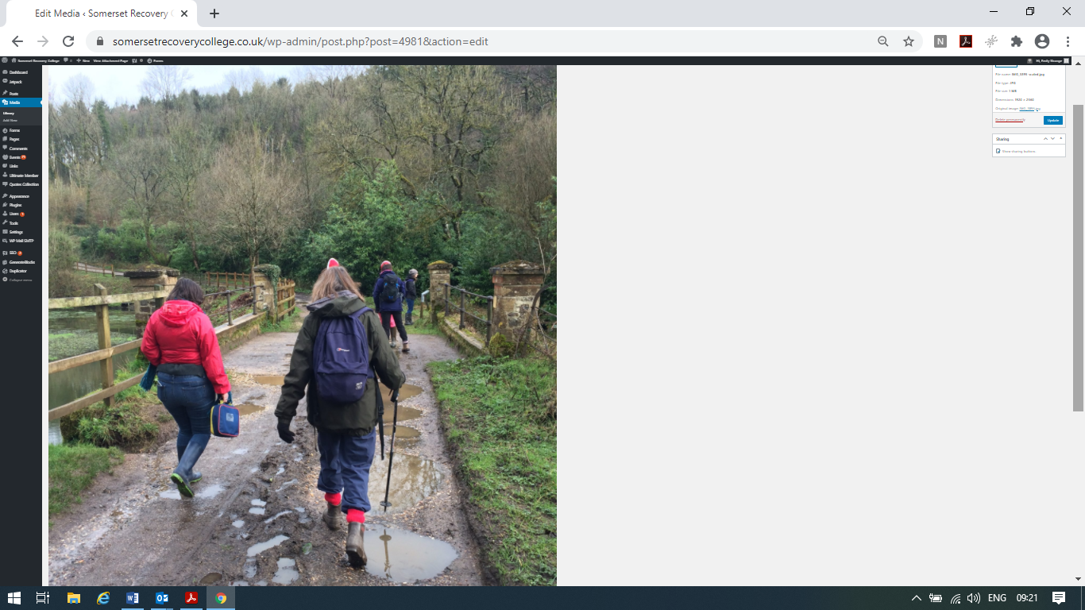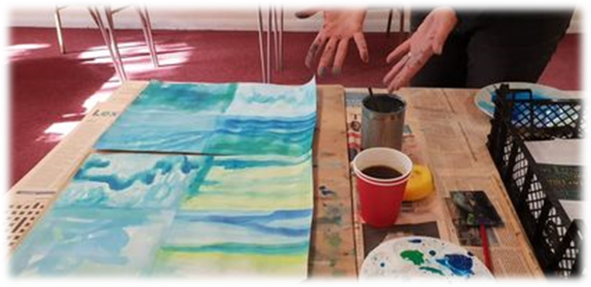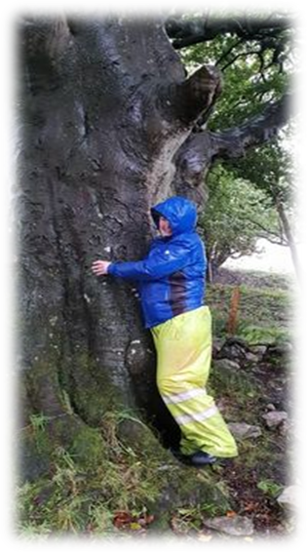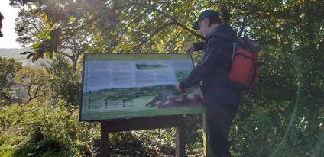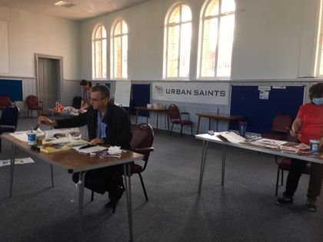

**Recovery Colleges offer educational courses about mental health and recovery which are designed to increase students' knowledge and skills and to help them feel more confident in self-management of their own mental health and well-being.**

**Opportunities Somerset Recovery College (SRC) can offer**:

* **Courses which teach new skills**

Our Recovery curriculum promotes learning to support personal journeys of recovery in several different areas, including:

Rebuilding Your Life

* around what we mean by Recovery
* around planning ahead for your wellbeing

Knowledge and Understanding

* about the experience of mental distress
* about mental health issues and treatments
* about ways to manage and live well with mental health symptoms

Developing Practical Skills

* to help manage a mental health problem
* to look after your own wellbeing
* to help you lead a productive and meaningful life
* to help you pursue your dreams and desires

Living Well and Enjoying Life

* by trying out and having the chance to experience new things
* by finding expression through art, music, creative writing and drama
* by discovering your hidden talents and sharing them with others
* by cultivating wellbeing through physical activity, intellectual activity, spirituality and creativity
* 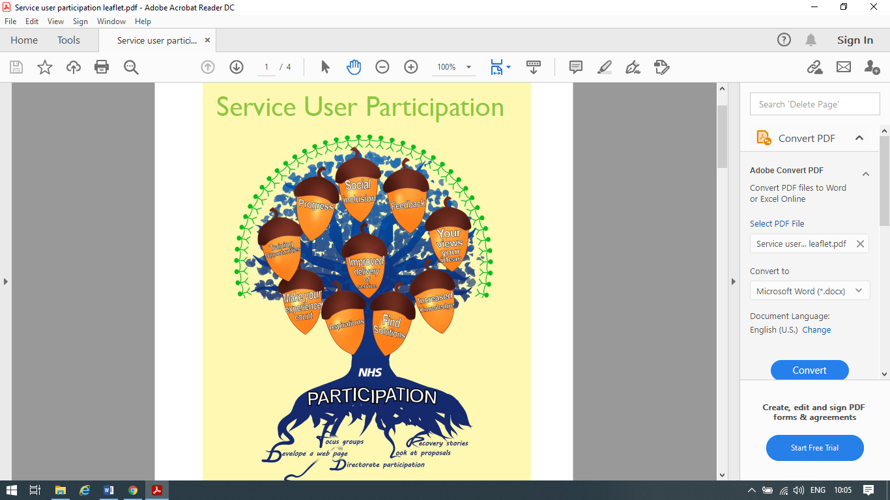**Co-production** design, develop, deliver and review of SRC courses
* **Recovery Partners** someone who has ‘lived experience’ of receiving care and treatment from mental health services or as a carer, and wants to participate in bringing about improvement in services by sharing their experiences and ideas. Becoming a Recovery Partner can also help build confidence, gain a sense of achievement and connect with others.

**Core Values**

**At Somerset Recovery College (SRC) our core values form the foundation for what we do. Our core values are:**

**1. Personal recovery**: Personal recovery has been described as “a personal journey of discovery” (Repper and Perkins, 2012). Recovery Colleges exist to help people along this journey, through discovering new skills and tools to promote and manage health and wellbeing. We use the CHIME Framework for personal recovery to describe our understanding of what personal recovery may look like. Using a framework ensures that we bring evidence based principles of recovery to our service, and enables the effectiveness of what we do is measurable.

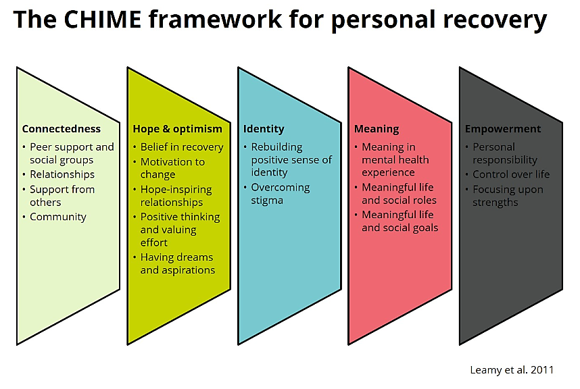

**CHIME is based on the following principles:**

|  |  |
| --- | --- |
| Connectedness | Having good relationships and being connected to other people in positive ways. |
| Hope & Optimism | Having hope and optimism that recovery is possible and relationships that support this. Including: motivation to change; positive thinking and valuing success; having dreams and aspirations. |
| Identity | Regaining a positive sense of self and identity and overcoming stigma. |
| Meaning | Living a meaningful and purposeful life, as defined by the person (not others). Including: finding meaning in mental ‘illness experience’; spirituality; meaningful life goals. |
| Empowerment | Having control over life, focusing on strengths, and taking personal responsibility. |

Somerset Recovery College is based on the firm belief that with the right support and opportunities people can and do recover from mental illness in such a way as to live meaningful and purposeful lives of their own choosing. Flourishing in personal recovery is possible! ‘Personal recovery’ is not always the same as ‘clinical recovery’:

1. **Personal Recovery**relates to regaining spirit, hope and energy, so that each person can begin to make choices of their own, regain control and move forward in their lives.
2. **Clinical Recovery**relates toresponses to medical and allied healthcare interventions and treatments provided through the knowledge and skills of mental health practitioners. This is usually orientated around the relief of symptoms and other clinical signs of illness. Clinical recovery can of course be part personal recovery (Slade, 2009).

Personal recovery includes:

* Making the best use of clinical interventions and treatments
* Acceptance of who we are and what we can do
* Acquiring knowledge and understanding in order to gain control of our lives
* Finding our own voice and being heard
* Taking (back) responsibility for our own recovery
* Discovering (or rediscovering) meaning and purpose
* Having hope for the future
* Being able to make our own choices
* Being able to assert our own needs
* Overcoming stigma or shame and feeling positive
* Giving back and helping others
* Living well despite symptoms of illness

**The goal of recovery is not to become ‘normal’. The goal is to embrace the human vocation of becoming more deeply, more fully human.**

**Patricia E. Deegan, (1996)**

**2. Co-production**: Co-production means all courses are co-designed and co-delivered between at least two people where there is a combination of “learned” knowledge and skills and a “lived experience” of mental health recovery. We proactively create opportunities for students to share their recovery stories and this an important source of empowerment, as it provides an opportunity to reduce the stigma around mental illness. Sharing our stories creates opportunities to support others who are having similar experiences; gives a voice to those who struggle to speak out; brings people together through shared experiences and offers opportunities to express and experience kindness and compassion.

Co-production tutor partnerships bring a range of expertise to the courses they deliver including:

* An in-depth understanding of recovery values and principles;
* Specialist knowledge of the subject they are teaching;
* Teaching, training or group experience;
* Subject-relevant experience of working in the field of mental health;
* Subject-relevant “lived experience” of mental health issues.

**3. Educational approach**: Somerset Recovery College is not a clinical service. Our tutors are not required to have access to medical or mental health case notes or clinical records and our courses are educational in nature rather than being classed as therapy or treatment. However, Somerset Recovery College courses can complement and enhance clinical care or clinical interventions. The focus of Somerset Recovery College is to actively engage students in recognising and developing knowledge, understanding and skills that can help them live well according to their personal definition of recovery and wellbeing.

People enrol on our courses as students (not patients) because *they* want to learn (not because they ‘have to’), accordingly they do not need a referral from a health practitioner nor do they need to be using mental health services to enrol on recovery college courses.

Our recovery curriculum promotes opportunities to support flourishing in personal recovery, including:

* Learning from others in a supportive and welcoming environment
* Empowerment to find new ways of managing and living well with mental health symptoms through developing practical skills:
* to help manage a mental health problem
* to look after your own wellbeing
* to rebuild your life, and find meaning in the journey
* Pursuing new opportunities to flourish

(Recovery is) a deeply personal, unique process of changing one’s attitudes, values, feelings, goals, skills and roles. It is a way of living a satisfying, hopeful and contributing life, even with the limitations caused by illness. Recovery involves developing new meaning and purpose in life as one grows beyond the catastrophic effects of mental illness.

Bill Anthony (1993)

**4. Free and open to all:** All our courses are free of charge and open access to any Somerset resident over the age of 18. Our students do not need to be accessing mental health services to attend our learning opportunities.

**5. Partnership working**: Somerset Recovery College is hosted by Somerset NHS Foundation Trust, in partnership with local organisations across the county to offer a wide-ranging and holistic approach to learning. Some of our partners include:

* The Balsam Centre
* Chard Watch Project
* Somerset Skills and Learning
* The Nurture Shed
* Mind in Somerset

**COURSE INFORMATION**

**What You Can Expect From Us:**

Before your course you can expect:

* To be given accurate information about the courses and prompt response to any query or complaint.
* To be informed in good time if there are any changes to your course.

When you attend your course you can expect:

* That your attendance and participation in courses will be kept confidential and that your tutor will not talk about your identity to anyone outside SRC.
* That your tutor will take into account any special need or request that you have made on your application form, and help you as much as possible to get the most out of your session.
* That you will be treated with respect and fairness by your tutor and your fellow students
* That your contribution will be received and valued.

You’re off to great places!

Today is your day! Your mountain is waiting. So…get on your way!

Dr. Seuss (Oh, The Places You’ll Go!)

As an SRC student, we aim to give you all the support and guidance you need to achieve success. The Code of Conduct is a guide to show you what we expect from students of SRC so that we can help you to find hope and opportunity in a supportive, accessible and non-threatening learning environment.

**As An SRC Student We Expect You To:**

1. Show respect to all students and staff, not use offensive or racist language, never discriminate or harass others and not to wear logo’s or slogans that could be offensive to others.
2. To respect the wellbeing and property of the other members of the community. SRC does not allow any threatening or aggressive behaviour, or any behaviour which disrupts the rest of the class. You can expect your tutors to prevent anyone from behaving in a bullying, threatening or disrespectful manner towards you. Equally you can expect to be warned if your behaviour is not acceptable, and you may then be asked to leave if it continues.
3. To take an active part in your own learning and use the resources made available to you.

1. To give us information that we need to support your enrolment.

1. To turn your mobile phones on silent/off during the session, unless you have particular reason for which you have agreed with the co-tutors otherwise.

1. To attend courses punctually. We would encourage you to try to arrive fifteen minutes before a course begins so that you have time to get a drink and not feel rushed.
2. To let us know if for any reason you can’t attend. If you need any additional advice or support outside of class time, please contact SRC on 07342 063735. Please be aware, course tutors are not available for any advice or support outside of classes.

1. To take responsibility for your own learning and come to the session equipped to participate.

1. To communicate your wishes as to how we can support your wellbeing whilst attending sessions. You are encouraged to stay in the class even if you don’t feel able to participate. If you are unwell, please remember that your tutors are not part of a clinical team and can’t offer treatment but of course, they will do their best to get you the help you need to stay in class, to go home or to get in touch with someone who can help.

1. To advise us of things that may be preventing you from getting the most out of your learning experience. If there is any activity that you find difficult or stressful, please let your tutor know.
2. To treat your tutors and your fellow students with respect and fairness, valuing everyone’s contribution and doing your best to get the most out of the session.
3. To refrain from the use of alcohol and illicit substances while attending courses, the Recovery Library and other SRC activities or events.

1. To maintain confidentiality for and about who you see attending courses and any personal information shared with you by other students. Photographs can only be taken with consent, this process will be managed by the course tutor.
2. Failure to adhere to the Student Code may unfortunately lead to exclusion from Somerset Recovery College.

**Student Wellbeing and Emergencies**



During a course, you may feel concerned for your wellbeing. For example, you may feel triggered by course discussion, disclose distressed feelings, or even mention suicidal ideas or thoughts of harming other people.

**Guidance If You Become Distressed or Unwell**

1. Think about risk management from your own perspective and make any needs known to the tutor prior to the course commencing.

2. It is your responsibility to communicate your needs to the tutor and to make a choice about how you can manage your thoughts and feelings.

3. Of course we know we are all on a journey and we are here to encourage and learn from each other, so if you find yourself feeling distressed in any way we will encourage and support you to take control and management of any difficult situation you may find yourself in.

4. If you become distressed or the tutors become concerned about your emotional wellbeing, the tutors will have a conversation with you if they feel able and if it seems safe to do so. If you do not wish to engage with the tutors, this will be escalated to the SRC Leads or Co-production Team Manager to ensure appropriate follow up action is taken.

5. In very rare circumstances tutors will have a duty of care to take action without your permission. This only applies when they have weighed up all available information and discussed their concerns with the co-tutor and sought to raise the issue with you.

6. If you or the tutor feel that immediate action is needed, they will talk to you first. The tutor will explain that they are worried about you and will ensure that you are safe and have somewhere to turn for support. If you or the tutor can wait until after the course or in a break this will give the opportunity to speak in private and not in front of others. If you feel it is pressing, the tutor may take you outside or into another private area to talk about the issue.

7. If you or the tutor believes there to be a risk of serious and imminent harm, whether to yourself or other people, please let the tutor know who best to contact. If you are unable to advise the tutor they may go ahead and seek assistance from your emergency contact, your care team or the emergency services and this may be without your permission.

8. If you feel that there is an immediate risk – for example, you believe that you are at risk of suicide, or if you have imminent concerns for your safety, or the safety of others the tutor will call an ambulance on 999. If there is a risk of violence or harm to other people, the tutor will call the police on 999.

9. If you become physically unwell during the course, the tutor will call your emergency contact to assist with getting you home. In an emergency, they will call an ambulance and may do this without your permission.



**Complaints and Feedback**

* We will ask you to complete an evaluation form at the end of the session. This lets us know what you think about the course and is really important to us. We will take all the feedback into account when preparing future sessions. If you have a complaint or problem, please let us know as soon as possible.
* We are keen for your learning experience to be a positive one. However, if for any reason this is not the case, please discuss concerns you have with the tutor on the day in the first instance.
* Be aware that each partner agency may have a slightly different complaints procedure to SRC, therefore it is best to contact the person you booked the course with directly.
* We do take all complaints seriously, and will ensure learning will be undertaken as a result of your complaint at one of our regular partner meetings.

**How We Use and Store your Information**

* The information that you give us on your registration form is kept confidential, and is available to SRC tutors, so that they know who you are and whether you have any special needs. It is also available to SRC staff and administrators so that we can keep track of who is benefitting from our courses and make sure that the access to them is easy and fair.
* Any personal and/or sensitive information about you will be handled and stored in line with the Data Protection Act 2018 and managed and stored in electronic form, under Somerset NHS Foundation Trust Standards of Information Governance laid down by Trust Policy and is always kept in a locked cabinet.
* All SRC reports, which are circulated more widely, don’t have any personal information in them.
* SRC do not have access to clinical records. In an event where the tutor becomes concerned about the safety of a student they may contact the students’ emergency contact. This would never be done without making every effort to gain the student’s consent first - except in an emergency situation.



.

**We want to hear from you!**

**Email us: enquiries@somersetrecoverycollege.co.uk**

**Phone us: 07342 063735**

**Follow us on Facebook:** **Somerset Recovery College**



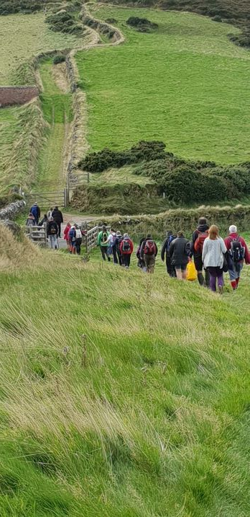**Individual Learning Plan**

**What Is An Individual Learning Plan?**

An individual learning plan (ILP) can help you to map your journey through Somerset Recovery College (SRC).

Setting learning goals can help you to get the right support from SRC, help you measure your progress, record your achievements and decide what your next steps will be.

We encourage you to use the ILP on your journey with us, however, this is entirely optional.

You can complete the ILP on your own, or with support from SRC staff.

**It Starts With A Goal…**

A goal can be described as a *roadmap* of where you are heading and the best way to get there (Chowdhury, 2020).

Research has shown that goals are linked with higher motivation, self-esteem, self-confidence, autonomy and success (Locke and Lathan, 2006, Matthews, 2015).

Setting goals gives our mind the power to imagine our ideal future: the way we want to see ourselves in years to come.

Goal setting not only helps you to complete the task, but also impacts wellbeing, represents your strive to achieve personal change, and enhances your meaning and purpose in life (Sheard, 2013).

When setting our goals, it can be helpful to follow the SMARTER model:

|  |
| --- |
| **S**pecific – Goals should be clear and concise.  **M**easurable – What does success look like? How is it measured?  **A**chievable – The goal or task must be challenging but possible. Gently pushing the limits encourages improvement and growth.  **R**elevant – Does the goal fit with your overall life goals and core values?  **Ti**me-bound – When will you finish?  **E**xciting – What enthuses you? The benefits should be worthwhile to maintain commitment.  **R**eviewable – Circumstances change. Revisit the goals and revise them if needed. |

It might be helpful to use the CHIME outcome measure as a way to set goals.

Setting goals is the first step from turning the invisible to visible.

Tony Robbins

**Using the CHIME Model to Set Goals**

**Instructions**

* Read each statement carefully.
* Draw a circle around the number that most describes how you feel about yourself at this point in time:

1= Absolutely not true about me

2=Somewhat true about me

3= Neutral

4= Mostly true about me

5= Absolutely true about me

**Scoring**

* Add up scores for each group individually.

**Results**

* Each group is scored out of a possible 15
* 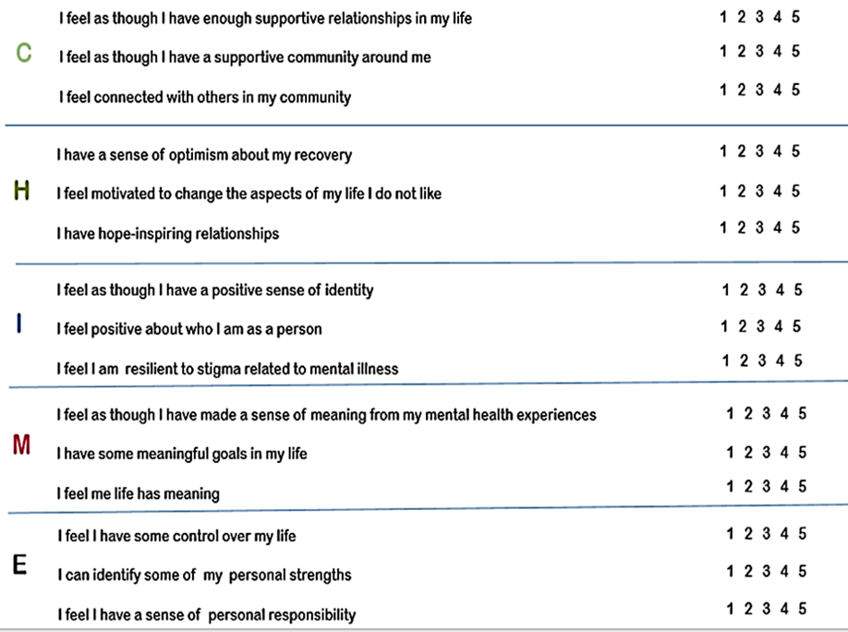The group with the lowest score is most likely to be an area of recovery you would benefit from working on improving – try setting a goal related to this area.

**Individual Learning Plan**

|  |  |
| --- | --- |
| **Name:** | **Date:** |

|  |
| --- |
| **Additional learning and support requirements:** |

|  |
| --- |
| **CHIME Results (write the score for each group)**  **C____H____I____M____E____**  **Which CHIME element will I work on with regards to goal setting?**  **How important is achieving this goal to me? (Please circle)**  **0…1…2…3…4…5…6…7…8…9…10**  **Not important at all Somewhat Important Extremely Important** |

**What helps me to achieve my goals now?**



|  |  |  |  |  |
| --- | --- | --- | --- | --- |
| **What goal would I like to achieve?**  **(Which CHIME group would I like to improve?)** | **What I need to do to reach my goal?** | **How can SRC support me?**  **What other resources do I have?** | **When will I**  **Complete this by?** | **How will I know I have met my goal?** |
| **Example: *Connection*** | ***Post a comment on the SRC Facebook Group.***  ***Attend a walking course where I can build up confidence talking with others*** | ***Ask SRC peer support worker to go with me the first day of the course so I feel less anxious*** | ***By the end of the course (6 weeks’ time)*** | ***I will have had a meaningful conversation with another student who I get along with and feel comfortable with.*** |
| **1.** |  |  |  |  |
| **2.** |  |  |  |  |
| **3.** |  |  |  |  |

**My Goals**

**Reviewing your Goals**

**Don’t let your goals remain a list of wishes** (Sutton, 2020).

* Goal setting is an effective way of focusing our attention on the right activities, energizing us, and increasing our commitment (Sheard, 2013).
* Goal setting provides you with a means to navigate through a complex world and can encourage your long-term persistence.
* It’s important to review a goal progress to make sure that you really are progressing and not just going around in circles

|  |  |  |  |
| --- | --- | --- | --- |
| **Questions to Consider** | **Goal 1** | **Goal 2** | **Goal 3** |
| **Is the goal still relevant? Goals are established based on your situation at the time of setting**  **them: has your situation relevant to this goal changed?** |  |  |  |
| **What has worked well?** |  |  |  |
| **What still needs work?** |  |  |  |
| **Is this goal easier or harder than expected?**  **(do you need to take smaller steps?)** |  |  |  |
| **How can you continue to work towards your goal?** |  |  |  |

**Increasing Participation**

Participation in everyday activities is a vital part of a healthy and balanced lifestyle.

Through participation we learn skills and abilities; connect with others and find purpose and meaning in life.

Participation is made up of many different elements. Each element contributes to participation in its own right, but also exists as part of a wider “eco-system” of participation. Each element of participation is not a solid construct but is made up of many “micro-elements”.

Participation is not always easy and sometimes we can find this challenging. But, rather than feeling overwhelmed by trying to increase participation as a whole, try to identify which “element” and “micro-element” in particular you may be struggling with. By working on improving those, you may find your participation increases.

Use the *Elements of Participation* posters to help you to do this.

|  |  |  |  |  |
| --- | --- | --- | --- | --- |
| **Element of Participation** | **Micro-Element** | **Why Is this Important to me?** | **How could I improve this Micro-Element** | **Resources to Help Me**  **(including people)** |
| ***Example: Motivation*** | ***Energy*** | ***I want to attend a course, but don’t have much energy because I am always tired; I struggle to keep to a bedtime routine*** | ***Increase my energy levels by addressing my sleep needs and adopting better sleep habits*** | ***Sleep diary***  ***Partner could encourage me to improve sleep habits and keep to bedtime routine*** |
|  |  |  |  |  |
|  |  |  |  |  |
|  |  |  |  |  |

**Notes**

|  |
| --- |
| Download HD Sketch Icon Of A Sticky Note - Sticky Notes Icon Png  Transparent PNG Image - NicePNG.com |