**Bernard Genge**

**Consultant, trainer, performance coach and business improvement/change specialist**

**bernard.genge@gmail.com Tel: 01460 61459**

Embracing change

Overview

Is it easy to embrace change? Yes and no, if you are at work and your boss said ‘I’m going to give you a 25% pay rise’, that’s change but acceptable change, but what about when our boss says ‘you are been made redundant’?

Your attitude toward life is affected by your ability to embrace change. If change happens to you, rather than you influencing that change, you are much more likely to feel like you are being dragged through life. Embrace change with a calm and relaxed mind, rather than an emotional one. Stage 1 is STOP – Stop, Think (about what change you need to make right now), Observe (where you are now, how it feels and how it could be if you make the change), Plan – which is what we will do in a moment.

In a dynamic, unpredictable world change is inevitable and embracing it allows us to develop and reach our full potential, if we resist change, we will never unleash our potential and express who we really are. The only constant in life is indeed change, it’s happening all around us every day and we have all made changes in our lives. So, what holds us back?

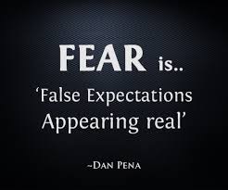 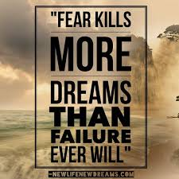

Never let your fear decide your future, so feel the FEAR and do it anyway because:

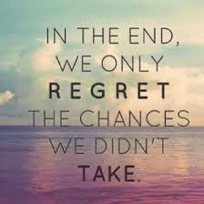

Once we have done stage 1 (STOP) and decided what needs to change we then need to create a massive ***‘PUSH’*** to change. We use the analogy of a ‘burning platform’, if you were stood on such a platform, the first thing you would feel is the heat under your feet, it would be uncomfortable. So, you need to create discomfort with your current situation, and you do this by creating images (google images are great), words, drawings and anything that provides you with discomfort.

Stage 3 after you’ve created that push is to create a ***‘MASSIVE PULL’*** to change. This is in the form of a compelling vision of what your life will be like when you’ve made the change.

Fundamentally we change for one of two reasons, inspiration or desperation, or put another way pain or pleasure and this is what we are creating. So, imagine the change I wanted to make is to stop eating processed and unhealthy food and embrace a healthy diet here is a burning platform followed by a compelling vision.

 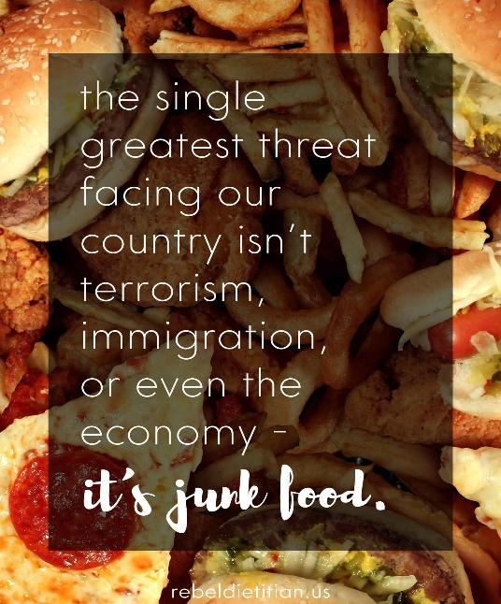 

Now my compelling healthy vision:

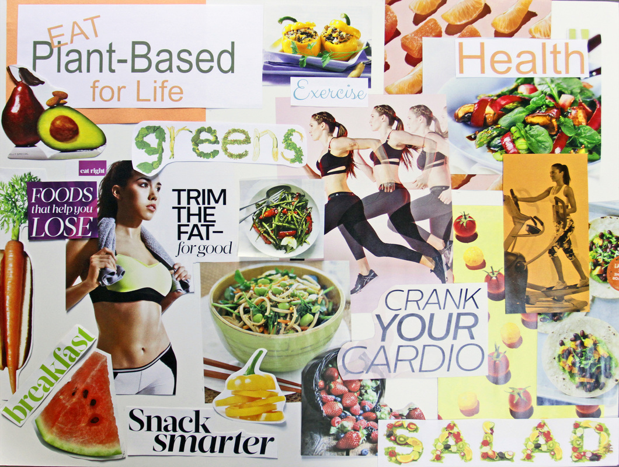

I would then refer to my burning platform whenever I feel like I’m slipping back into my old habits, but my compelling vision board I put somewhere where I see it every day so I have a constant reminder of where I am heading.

Stage 4 is to create a plan to go from your burning platform to your compelling vision. Set yourself SMARTER (Specific, Measurable, Achievable, Realistic, Time-bound, Exciting, recorded) goals and plan what you will do every week to take yourself in that new self-chosen direction. Then you need commitment to yourself to do your weekly commitments and self-integrity. You may even need an ‘accountability partner’.

Tools that can be part of a ‘change toolkit’:

* Diffusion of innovation
* Loss/gain to create urgency
* SWOT to help prioritise the weaknesses and threats that need to be overcome
* Identifying driving and restraining forces working for and against the change
* 6 thinking hats

**bernard.genge@gmail.com Tel: 01460 61459**