**[bernard.genge@gmail.com](mailto:bernard.genge@gmail.com)**

**Focusing on what you can Influence**

People often complain and moan, and like to focus on the things they can do very little about. It is the course of least resistance: if we complain, our brains think that we don’t actually have to do anything; it is easier than focusing on things we could do because we will then have to stretch our comfort zones and take action.

Most people don’t realise how much they complain because it has become second nature; it is natural to initiate or be drawn into complaining conversations and it has become so familiar that it just seems ‘normal.’ Many people have the mistaken idea that it is a good conversation starter because it is easier to find common ground by complaining. People also complain because they want other people ‘on their side.’

Apart from having a negative and disempowering impact on other people, it can have a detrimental effect on our health (both physical and mental), our personal performance and our relationships. No one wants to be seen as a moaner; we would much rather be seen as a doer.

By using a simple tool such as the ***Circle of Concern***/***Influence***, you can make a great start in creating a more positive approach and develop your levels of commitment and influence within your life.

**The Process**

Firstly, you need to decide the sort of person you want to be. Do you want to be more positive with a focus on the things you can do something about? Do you want to be seen by others as someone that gets things done? Next, you need to use honest self-awareness to assess how positive you are at the moment and how well you focus on the things you can actually influence. Test your current thoughts with what others think. Finally, draw the diagrams below and identify your concerns within your circle of concern.

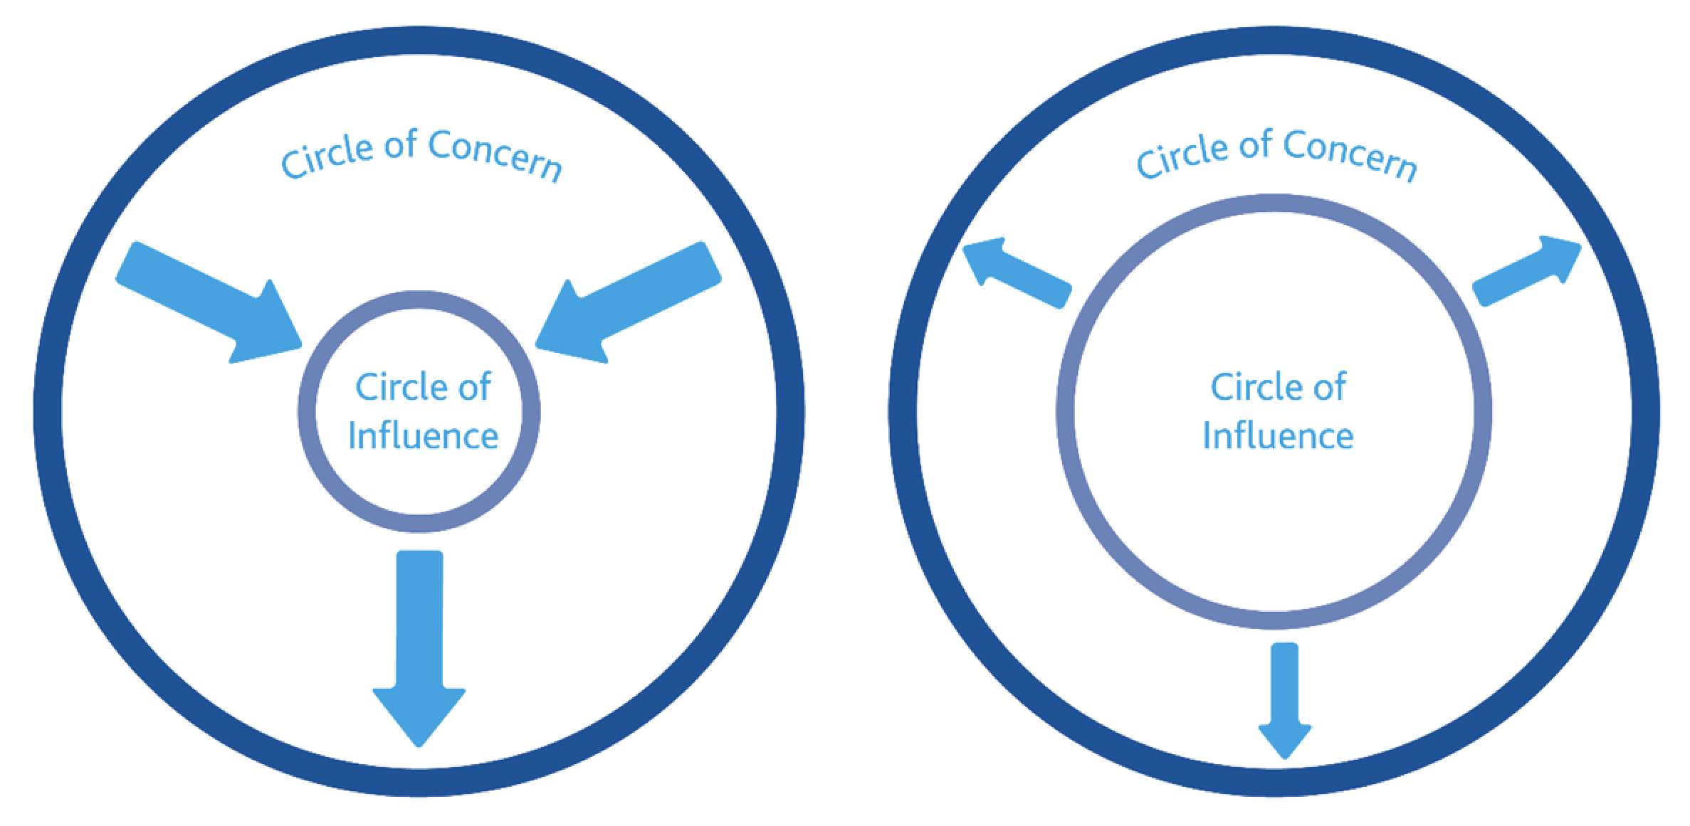

Many people spend too much time focused on those things that concern them and not enough on those they can influence, which leads to their circle of influence becoming smaller.

When you have written down your concerns in the circle of concern (in the left diagram above), you will classify them into:

* No Control (**NC**) – things you can do absolutely nothing about. You will acknowledge these and accept then, but give them no further time.
* Indirect Control (**IC**) – things you can influence indirectly because someone else will make the final decision. If you focus on these, you will decide who you need to influence and how.
* Direct Control (**DC**) – things you can directly control; you will decide what action you will take.

Once you have done this, you can then use the ***Pareto Principle*** (roughly 80% of the effects come from 20% of the causes) to identify the 20% of **IC/DC** concerns that you will focus on and resolve. Using the diagram on the right above (the smaller circle of concern with the arrows pointing outwards), write the 20% of concerns you have and then in the inner circle start writing the things you will do to influence an outcome. Use a different coloured pen for different concerns and the action you will take within your circle of influence. Decide how you will hold yourself to account. Will you tell someone else and ask them to hold you to account?

The next step is to turn the items in the circle of influence into an action plan, and then take action and review progress regularly, probably weekly. Do this for 30 days, completely focusing on those concerns you can influence and do something about and refrain from focusing and complaining about those things you cannot. Assess the change in your personal effectiveness when the 30 days are up.

**Key Points and Practical Tips**

* If you have ever received feedback regarding complaining or moaning, use this to refocus your mind.
* Use this to process concerns you have in the future and to put them into perspective.
* Classify those concerns into those you can and those you cannot do anything about.
* Use the ***Pareto Principle*** to identify the 20% of concerns you will focus on.
* Identify the action within your circle of influence that you will take.
* Create an action plan.
* Take action.
* Review your progress and hold yourself to account.

**The Benefits**

* Engages commitment within yourself to resolve concerns.
* Focuses valuable time away from complaining and towards taking action.
* You become a person of influence and thereby influence others to process their concerns in this way.
* Deepens accountability and the taking of responsibility.
* With consistent use of this important strategy, you resolve your own issues and make things happen.

[bernard.genge@gmail.com](mailto:bernard.genge@gmail.com)