**WHAT IS IT**

Is a useful technique for understanding the Strengths, Weaknesses, Opportunities and Threats involved in a project or in an organisation (CIPD, 2015).

.

**SWOT** stands for:

* **S**trengths
* **W**eaknesses
* **O**pportunities
* **T**hreats

It is important to remember that the Strengths and Weaknesses are regarded distinctly as internal factors e.g. factors relating to services, products, pricing and cost. Whereas the Opportunities and Threats generally relate to external factors e.g. factors relating to markets, sectors, politics, environment, technology etc.

**THE PROCESS**

The SWOT analysis starts by conducting a review of internal strengths and weaknesses in the organisation. Then note the external opportunities and threats that affect the organisation.

To help carry out an SWOT analysis answer the following questions.

**STRENGTH**

* What does the organisation do well?
* What resources do you have?
* What advantages do you have over your competition?
* What do people in your market see as the strengths?

**WEAKNESSES**

* Which areas might you improve?
* What should you avoid?
* What are people in your market likely to see as weaknesses?
* What factors impact your reputation in a negative way?

**OPPORTUNITIES**

* What good opportunities can you spot?
* What interesting trends are you aware of?

**THREATS**

* What factors are potential threats to your organisation?
* What are your competition doing?
* Is changing technology threatening your position?
* Could any of your weaknesses seriously threaten your organisation?

**THE BENEFITS**

* It is a simple four box framework
* It is flexible
* It is relatively quick
* It enables an understanding of the strengths and weaknesses of the organisation.

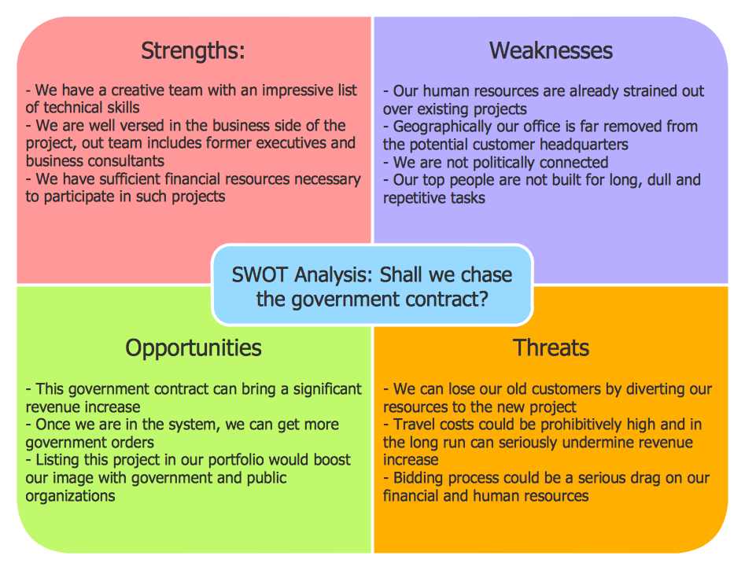

* It allows a management team to focus on strengths and build opportunities