WHAT IS - conflict resolution

WHAT IT IS
Conflict resolution is the process by which two or more parties reach a peaceful resolution to a dispute. It is a of course normal part of any healthy relationship. After all, two people can’t be expected to agree on everything, all the time. The key is not to avoid conflict but to learn how to resolve it in a healthy way.
When conflict is mismanaged, it can cause great harm to a relationship, but when handled in a respectful, positive way, conflict provides an opportunity to strengthen the bond between two people. Whatever the cause of disagreements and disputes, by learning skills for conflict resolution, you can keep your personal and professional relationships strong and growing.

THE PROCESS
It starts with self-awareness and an honest assessment of your current style for dealing with conflict and understanding when it has worked and not worked in the past. There are five conflict styles as per the diagram below, the key is knowing when to use each:
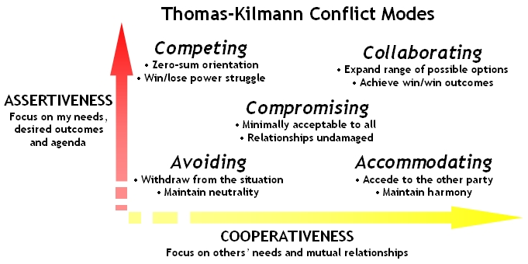
Accommodating (it would be my pleasure). Here the goal is to “yield” by ignoring your concerns in order to satisfy the concerns of another person which can be seen as selfless generosity or obeying others. Useful for keeping the peace, creating good will or when the issue is of low importance to you.
Avoiding/withdrawing (I’ll think about it tomorrow). The goal is to delay because you do not satisfy own concerns or concerns of others and you maybe stalling on an issue, or ignoring it. Useful for buying time, allowing others (and you) to cool down or when issue is not the real cause of the problem.
Competing/forcing (my way or the highway). Goal here is to win by asserting your position without considering opposing viewpoints. May be seen as standing up for your rights, or throwing your weight around. Useful for quick action, if you have to make an unpopular decision, for vital issues where you need compliance. You might also use this to protest yourself when in a very challenging situation where your back is against the wall.
Compromise (let’s make a deal or come to a temporary agreement). Here the goal is to find a middle ground, by forgoing some of your concerns in order to have others met, so it is negotiating, or splitting the difference. Useful for a temporary solution, where there is time constraints or as a back-up when collaborate or compete fail.
Collaborate (two heads are better than one so let’s listen to each other and find a way forward that neither of us could find on our own). The goal is to find a win-win situation because you are fully concerned with satisfying both sides of an issue. It is working with the other person to find an optimal solution. Useful for gaining commitment because the concerns of both parties are too important to compromise. It is merging perspectives on important issues, with an end result of building a great relationship with the other person.
Use a structure for the conversation such as the one below:
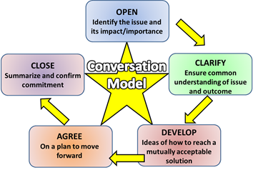
Finally, use your self-awareness regularly in the future, to review your ability to resolve conflict effectively.
KEY POINTS AND PRACTICAL TIPS
- Know how you deal with conflict now - do you avoid it, accommodate others too easily, are you too forceful and then create defensiveness in others or do you collaborate or compromise effectively?
- Prepare – if you fail to plan, you plan to fail.
- Use a structure for the conversation such as OCDAC above.
- Be flexible.
- If it gets heated agree an adjournment
- Know the boundaries – what is acceptable and unacceptable during the conversation
- Focus on the outcome, not personalities
- Agree the follow up – vital for long term commitment to the outcome
- Know when there is a need for an independent facilitator

THE BENEFITS
- Encourages open-mindedness (in you and others).
- Prevents groupthink where people conform with the group, so they don’t feel an outcast which can lead to bad decision making.
- Achieving results with the commitment (not just compliance) of others.
- Better understanding between people.
- You become more confident, more decisive and build good healthy relationships.
- More ideas leading to better creativity and productivity.
- It can be a signal of a need for change.
SUMMARY
Use your self-awareness to think back to times you’ve experienced conflict and ask yourself ‘what was the underlying cause, what was your thoughts/mindset about it, what conflict style you used and what was the outcome’?
In the future can you see conflict as something to be embraced (in the right way) as it can build relationships, solve problems, understand other people and a something that prevents ‘group think’.
Always remember to:
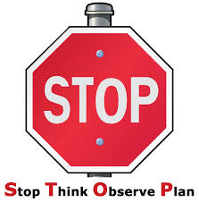
FIND OUT MORE
https://www.youtube.com/watch?v=PFIydyH2H8Y
Thomas Kilmann Conflict Mode Instrument
The Thomas Kilmann Conflict Mode Instrument is based on a five-category scheme for classifying interpersonal conflict-handling modes: competing, collaborating, compromising, avoiding, and accommodating.

